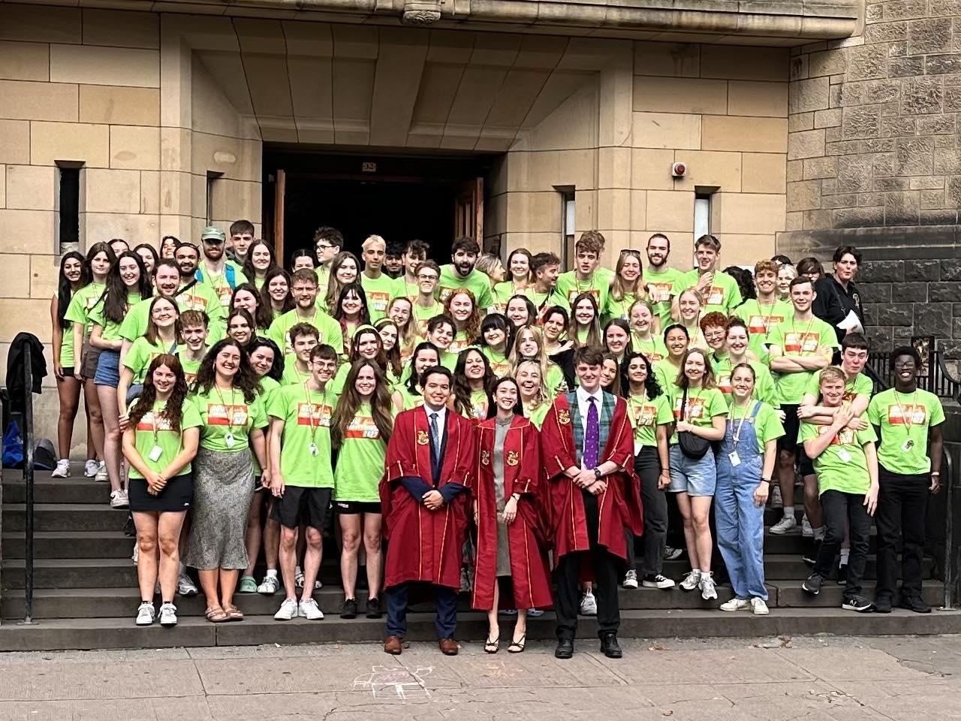

- Please ensure you have read through the Freshers’ Helper page on our website: guu.co.uk/helping
- Please complete this application and upload it as part of the application form
- We will NOT consider applications without a blank canvas.
- Deadline for applications: MONDAY 29th APRIL (9PM)
- Interviews will be held in person in May

*IMPORTANT* Please note that you must be available from Wednesday 12th September 2024 to Sunday 22nd September 2024 inclusive. If you are unavailable at any point during this period, please contact the Honorary Secretary (honsec@guu.co.uk) to make us aware of your circumstances before handing in this form.

1
The Questions

Please keep your answers concise (this does not mean single sentences).

1. What has motivated you to apply to be a GUU Freshers’ Helper in particular: Why do it with us instead of GUSA, the SRC or the QMU?

2. If you could construct the ideal Fresher Helper, what FIVE qualities would they have?

3 . Freshers’ Week is ten days of madness and fun. Tell us a unique experience you had in the Union.

4 . Freshers’ Week is a time when we can try out new events to make sure people never leave. What new, one-off or themed event would you like to see during Freshers’ Week 2024? (No budget, no restrictions (Laws of Physics still apply, absolutely anything!)

5. Make up a new chant for the GUU that could get Sir Anton’s attention, silence GUSA, piss QMU and SRC off or could sell the Union to freshers.

6. You walk into the Beer Bar and see a quiet group of Freshers looking intimidated by a nearby group of confident and loud Freshers. What do you do?

The Blank Canvas

Use this section to express your creativity and show us why you would be an ideal Freshers’ Helper. In the past applicants have submitted music videos, TikToks, songs, poems, drawings, graphic design, posters, slideshows, dance performances, drinking games, crosswords, board games, parodies, memes, podcasts and blogs - think outside the box.

This section is the best way to make your application stand out, so take your time. Be as creative and unique as possible!

Please upload your masterpiece to the same google form as a separate file to this application. Should you have any issues with uploading your Blank Canvas, please contact Selena: honsec@guu.co.uk

Important note: We will not consider applications without a Blank Canvas.

